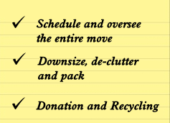

MOVING, LIQUIDATING AN ESTATE, LOOKING TO SELL YOUR ANTIQUES OR JUST DOWNSIZING?
UNABLE HOLD AN ESTATE SALE OR TAG SALE?
ONLINE AUCTIONS ARE THE BEST SOLUTION!
DENNIS AUCTION CAN HELP!
We at Dennis Auction have pioneered the way with performing online auctions. We have been doing online auctions in conjunction with live auctions for over 25 years.
Our knowledgeable staff are prepared to:
- Provide a free assessment of the items you need to dispose of.
- Assist with safe, timely transportation of your items to our location. Deadlines are our specialty!
- Prepare your items for auction, including research, photo’ing and describing your items.
- Provide you with an accurate description of items sold.
We can be contacted via email at: info@dennisauction.com or via phone at 908-859-3424 .
Check out our website at: www.dennisauction.com
Dennis Auction is a 3rd generation company with experienced, dedicated & caring staff. In these troubling times we are here to help you. Be well & be safe.

